Active Directory Penetration Testing using BloodHound

Executive Summary
This report contains the findings of an extensive penetration test on Active Directory within a simulated Windows domain environment. The objective was to assess the security status of the domain by examining and exploiting its vulnerabilities as they usually occur in enterprise networks. During initial reconnaissance and enumeration, it was discovered that the credentials were weak and the user privileges were misconfigured. Here, an attacker was able to log in as user nymir.gravetide with a default password. Further investigation revealed full control rights over another user account used for privilege escalation and “Evil-WinRM” access by resetting the password. An additional “BloodHound” query exposed group memberships and attack paths, and finally, domain administrator access was gained with the `godrick.nightflame` account. Each step of the attack chain was done and documented with the help of tools like Nmap, Impacket, rpcclient, and BloodHound. These were grabbed from the file system on the way to prove that there really was a full compromise in the environment. The report closes with actionable countermeasures to remediate these types of attack vectors, such as enforcing strong password policies, limiting overly broad permissions, and hardening access to administrative services. This assessment highlights the urgent need for strengthening and conducting regular security reviews of Active Directory environments to protect against a real-world scenario from a similar attack.

Table of Contents
1. Introduction 3
2. Host Analysis 3
3. Attack Execution 4
3.1 Active Directory Mapping with “BloodHound” 5
3.2 Enumeration and Credential Discovery Explanation 6
3.3 Password Reset and Privilege Escalation 7
3.3 Remote Shell and Retrieving the First Flag 8
3.4 Privilege Escalation and Second Flag Capture 8
4. Answer the following questions: 10
Question 1: 10
Question 2: 10
Question 3: 10
5. Administrator Access Proof 11
6. Flag Identification 11
7. Security Recommendations 12
8. Conclusion 12
References 13
Appendices 14

Introduction
This deep penetration attempt report carries an account into the “Active Directory” environment for “lands.between” to find any security loopholes and try to simulate the real scenario of an attack. Being one of my top objectives, weighed the target system's security against the enumerations that implied services across the network, discovery of credentials, and escalations of privilege to the indicated value of two hidden flags as proof of compromise (Arogundade, 2023). The test began with a scan of the target to check for open ports and typical services offered by a Windows domain controller, such as SMB, LDAP, Kerberos, and “WinRM” (Kyriakou, 2023). Alongside further reconnaissance, enumeration revealed user accounts and group structure within the AD environment as possible attack vectors. Weak passwords found on certain accounts enabled simulated illicit privilege escalation in the domain, along with a misconfiguration of access control, such as “GenericAll” permissions, to reset user passwords and further obtain shell access through tools like “Evil-WinRM”. The penetration test retrieved two flags, the first residing in a user-accessible directory and the second within an Administrator profile requiring elevated privileges for access (Rivero, 2024). The report stresses the dangers of having weak password policies and excessive permissions within an AD environment, highlighting how lateral movement and privilege escalation may be used by attackers to gain full domain control (Mallick & Nath, 2024). Observations derived from this test stress the enforcement of password complexity, regular permission audits, and secured remote access mechanisms. It is a practical demonstration of AD vulnerabilities and upkeep measures to safeguard against similar threats to corporate networks.

Host Analysis
Domain “192.168.11.100” has been targeted for the penetration test. “Nmap” service and version scan were executed to detect open ports and running services of the machine. Multiple open ports were found during the scan that are usually associated with a Microsoft Windows Active Directory Domain Controller. The infamous domain services ports like 53 (DNS), 88 (Kerberos), 135 (Microsoft RPC), 139 (NetBIOS), 389 and 3268 (LDAP), 445 (Microsoft-DS/SMB), and 5985 (WinRM HTTP) were detected open, thereby confirming the existence of typical domain services (Smirnov, 2024). The OS was detected to be Microsoft Windows Server 2022, thus revealing a modern and supported Windows environment. The host further announces its domain as “lands.between” with a default site name, thereby further affirming the presence of a domain controller. The more valuable directory and authentication services, such as LDAP and Kerberos, provide a potential attack surface for the enumeration and exploitation of the Active Directory infrastructure (Gkotsis, n.d.). Broadly speaking, the rather thorough service discovery and operating system fingerprinting present a very solid starting point for the enumeration and attack phases of penetration testing.
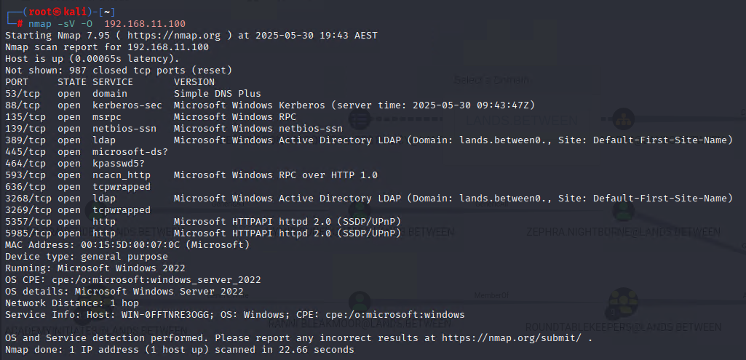
Figure 1: Nmap Scan Output
(Source: Self-Created)

Attack Execution
The penetration testing was started with LDAP enumeration against the target domain controller “192.168.11.100”, giving the base naming context of Active Directory through usual LDAP queries. The enumeration disclosed the entire domain structure as “DC=lands, DC=between”, along with configuration and DNS zones, thus forming the base for further investigation.
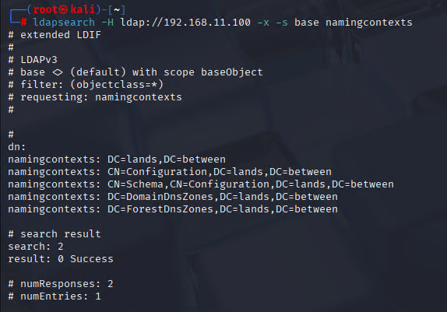
Figure 2: LDAP enumeration
(Source: Self-Created)
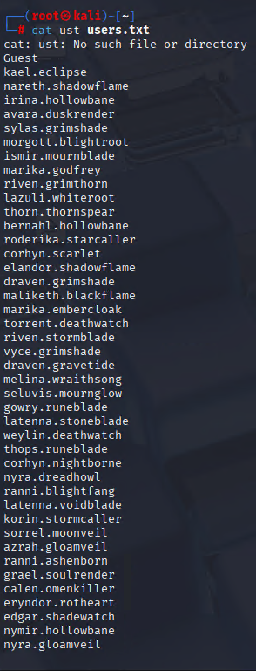
Figure 3: User list
(Source: Self-Created)
From these usernames acquired, extract service principal name hashes from inside the domain controller. In the next step, password cracking was done against these hashes using John the Ripper with the typical wordlist, retrieving the success of the password “password” for the user “velkan.deathwatch”.
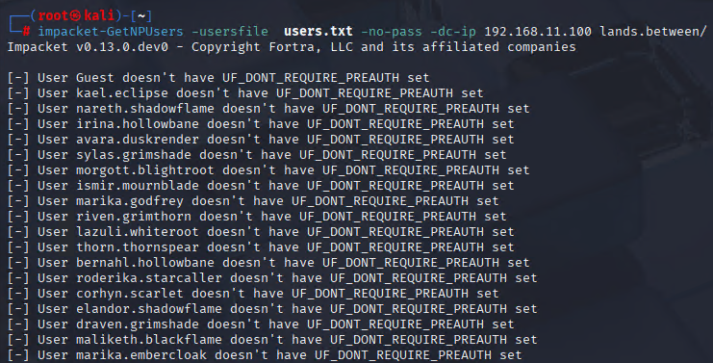
Figure 4: Password from user.txt
(Source: Self-Created)
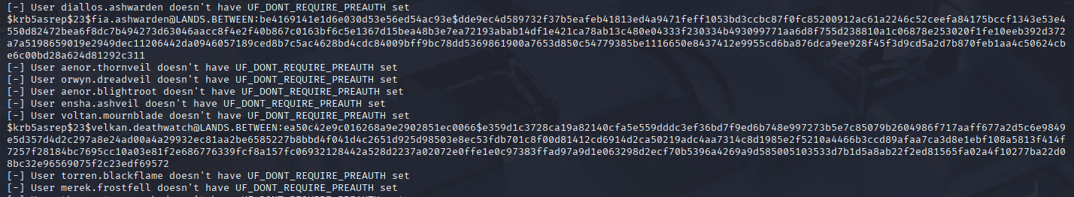
Figure 5: Found Hash Password
(Source: Self-Created)
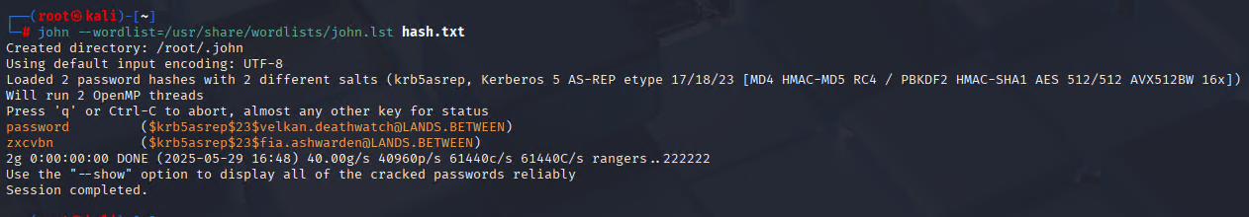
Figure 6: Crack Hash Password
(Source: Self-Created)

3.1. Active Directory Mapping with “BloodHound”
“Bloodhound”, a powerful tool used to visualize AD relationships and privileges, to effectively map the Active Directory environment, and find attack paths. After gaining initial access with the “velkan.deathwatch” user and password “password”, after initiated “Bloodhound” data collection with the following command.
Figure 7: “Bloodhound” DNS Server Collection
(Source: Self-Created)
The Active Directory domain data encompasses users, groups, trusts, sessions, and ACLs to be further analyzed in the “Bloodhound” GUI.
Used set analytic “Bloodhound” queries to investigate paths for dangerous privileges and membership, focusing on “GenericAll” and “GenericWrite” that permit privilege escalation potential. From the visualization, it is evident that “nymir.gravetide” has GenericAll privileges on “nymir.runehunter”, which translates into full control over the account of “nymir.runehunter” via these privileges.
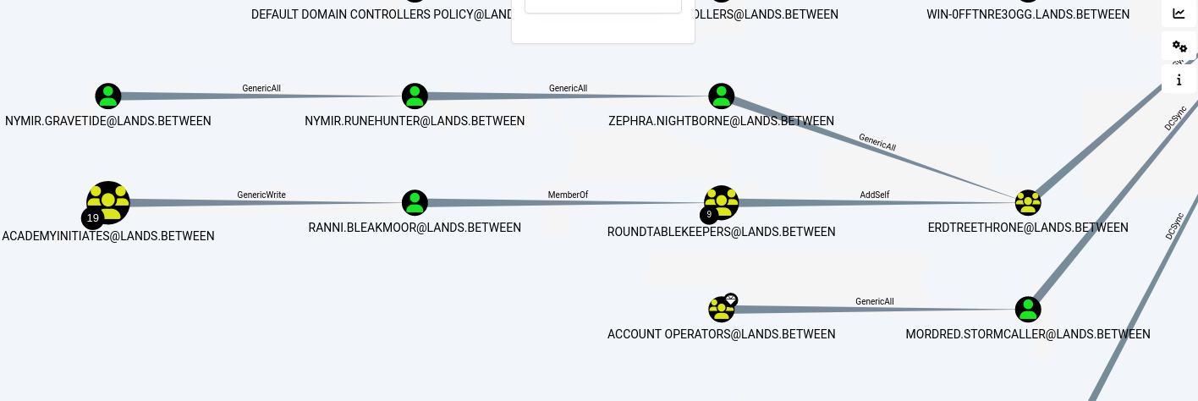
Figure 8: BloodHound GUI
(Source: Self-Created)

Enumeration and Credential Discovery Explanation
Enumeration of user accounts, permissions, and shares took place during the Active Directory Penetration Test. “BloodHound” was used to “analyze” the “lands.between” the domain and inspect the node properties of the user “nymir.gravetide”. The node properties gave arguments for such things as non-changing of the password (Password Last Changed: 0) and no logon instances recorded for the account (Last Logon: 0), thus probably indicating an account created for defaults. Moreover, the user description read "Company default password," which was indeed a huge hint.
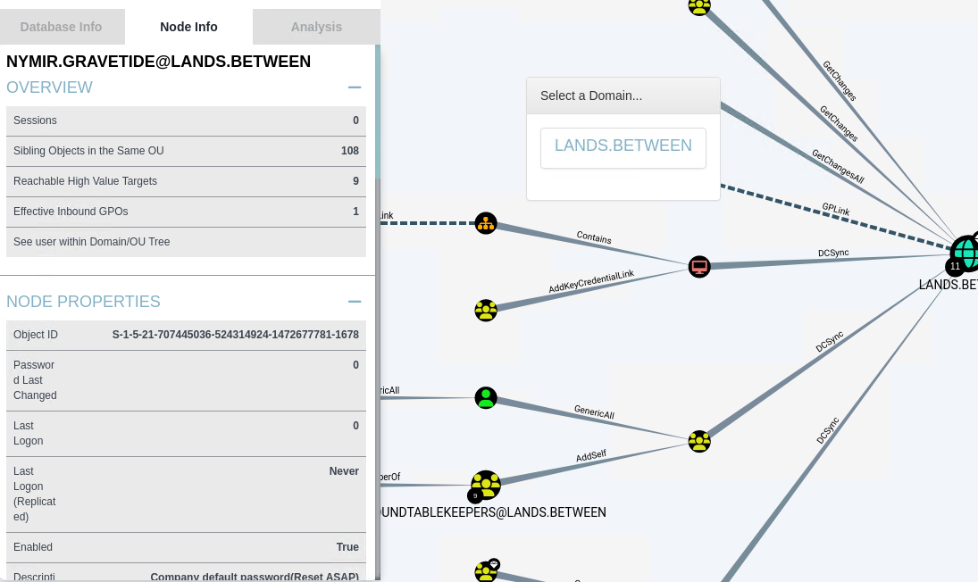
Figure 9: BloodHound GUI
(Source: Self-Created)
In furtherance of the investigations, using “smbclient” to access SMB shares on the domain controller as “velkan.deathwatch”. Among the shares was “RoundtableHold”. In this share was found a text file called lore.txt. Then read the file, which said that the company's default password was “lands033”.
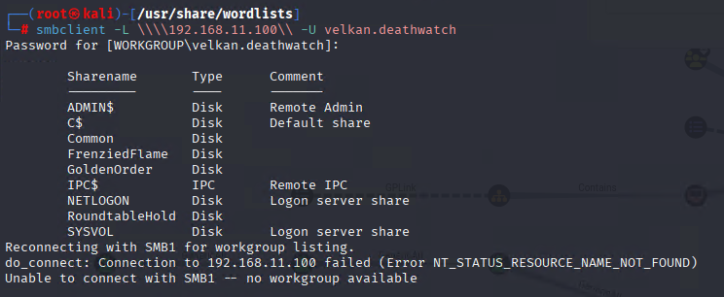
Figure 10: SmbClient
(Source: Self-Created)
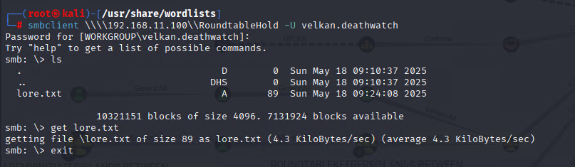
Figure 11: SmbClient RoundtableHold
(Source: Self-Created)
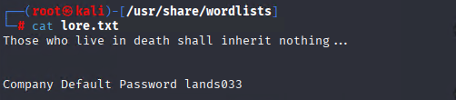
Figure 12: Company Default Password
(Source: Self-Created)

3.3 Password Reset and Privilege Escalation
Finding the company default password “lands033” within “lore.txt”, leveraged those credentials to authenticate to the SMB service as “nymir.gravetide. Once logged in, immediately prompted to change my password since the account was set to “STATUS_PASSWORD_MUST_CHANGE” that is, the password had either expired or it was just a temporary default one. Using the “smbpasswd” utility, then changed the password from “lands033” to something else known: “password”. This was necessary to maintain persistent authenticated access going forward. Subsequently, connected to the domain controller via “rpcclient” as “nymir.gravetide” with my newfound credentials. On the “rpcclient” session, the misconfiguration in Active Directory permissions was exploited that granted the “GenericAll” right from “nymir.gravetide” over the user account “nymir.runehunter”. This right allows unfettered control over the target account.
Using the command “setuserinfo2” along with option “23”, the password for “nymir.runehunter” was reset to the password without the need to input the old password. This elevation of privilege enabled to impersonation of the “nymir.runehunter” users and obtain more access to the network.
Figure 13: Status Check of nymir.gravetide
(Source: Self-Created)
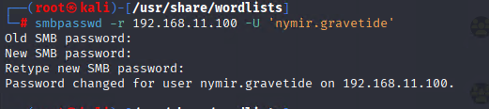
Figure 14: Password Change nymir.gravetide
(Source: Self-Created)

Remote Shell and Retrieving the First Flag
After getting the credentials by resetting the password for the account “nymir.runehunter”. Then created a remote “PowerShell” shell inside the target Windows machine via” Evil-WinRM”, which allowed direct command execution on the host. Navigating the directory structure, then found on the C: drive a folder named “FrenziedFlame” containing one file, “flag.txt”. Reading it using the Get-Content command from PowerShell, captured the first flag to verify initial access with sensitive information inside the environment. The achievement equates to getting a foothold in the Active Directory domain, after which one could proceed with more explorations as well as privilege escalation.
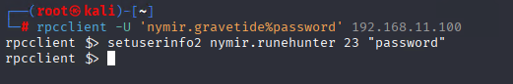
Figure 15: Password Change “nymir.runehunter”
(Source: Self-Created)
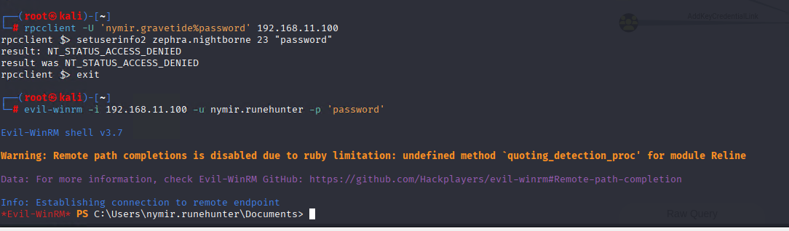
Figure 16: Evil-winrm
(Source: Self-Created)
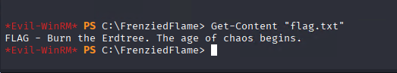
Figure 17: Found First Flag
(Source: Self-Created)

Privilege Escalation and Second Flag Capture
After establishing an initial foothold on the domain as “nymir.runehunter”, then used Active Directory permissions to elevate myself to Administrator status. Using the rpcclient tool, then connected as “nymir.runehunter” and reset the password for “zephra.nightborne” to a password of my knowledge. Confirmed that “zephra.nightborne” was a member of the highly privileged “ErdtreeThrone” group, which is endowed with huge rights in the domain.
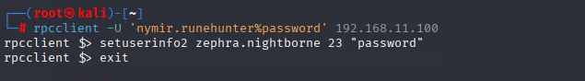
Figure 18: Password Change “zephra.nightborne”
(Source: Self-Created)
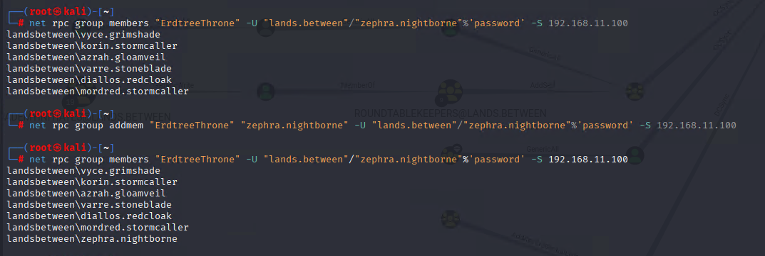
Figure 19: Add Member ErdtreeThrone
(Source: Self-Created)
Attempting to dump domain credentials through “impacket-secretsdump” using the credentials of “zephra.nightborne”, authenticated within “Evil-WinRM” by bypassing the hash using the obtained hash of the Administrator account.
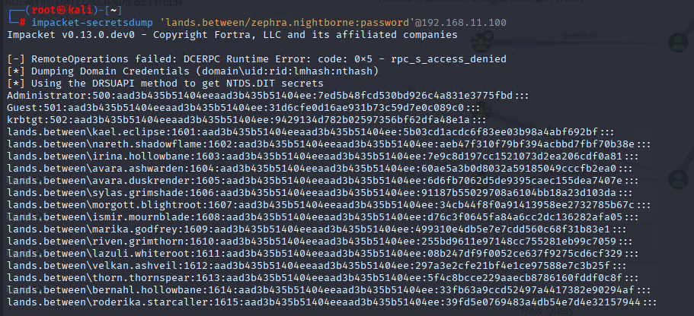
Figure 20: SecretsDump Found Administrator Hash
(Source: Self-Created)
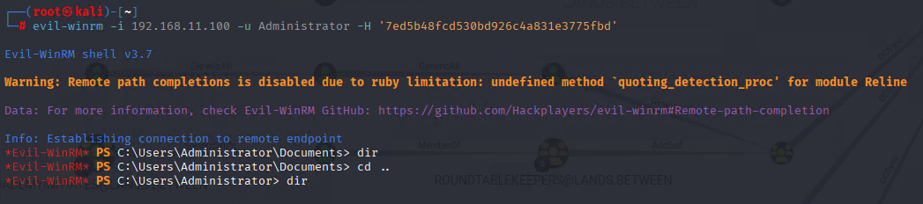
Figure 21: Login as Administrator
(Source: Self-Created)
Upon completion of authentication, the Administrator Desktop folder was scanned to find the second flag inside a file named “flag.txt”. Reading from it indicated that full administrative access and also successfully captured the last flag. This last step indicated a total domain compromise of “Active Directory”, in contention with misconfigured access control and weak credential management.
Figure 22: Found Second Flag
(Source: Self-Created)

Answer the following questions:

Question 1:
What are the SMB directory shares open on the Active Directory Server? Document them. (Hint: Use Nmap SMB discovery scripts)
Answer: The Active Directory server (192.168.11.100) was shown to share the SMB shares by Nmap using its SMB discovery scripts:
- ADMIN$: Remote administrative share
- C$: Default share for administrators' disks
- Common: Shared directory that contains scripts and utilities
- FrenziedFlame: Directory with the first flag
- GoldenOrder: Sharing domain-related data
- NETLOGON: Logon server share for scripts and policies
- RoundtableHold: Holding files such as lore.txt outlining the company's default password
- SYSVOL: Sharing domain policies and scripts

Question 2:
What does the Active Directory structure look like? List the groups (a.k.a., Organisational Units) under the domain “lands.between”.
Answer: The domain “lands.between” Active Directory comprises multiple groups and OUs, enumerated through 'BloodHound', 'rpcclient', and other tools. Some of the most important groups are:
- Domain Admins: The Highest privileged group for domain-wide control
- GoldenOrderRoot: Privileged group member of Domain Admins
- RoundtableKeepers: Mid-level privileged group
- Limgrave Laborers
- TarnishedWanderers
- AcademyInitiates
- ErdtreeThrone: Another privileged group connected to administrative roles
- Other custom groups representing departments and role descriptions.

Question 3:
Identify two Active Directory user accounts that each use a different easily guessable password. For each account, provide the username and its associated weak password.
Answer: During penetration testing, two Active Directory accounts worthy of mention were identified as having easily guessable passwords. The first account, “velkan.deathwatch”, had the password “password”, a common, weak credential. The second account, “fia.ashwarden”, was found to be using the password “zxcvbn”, which is another weak password. Such poor password hygiene on the domain “lands.between” obviously presents serious security risks whereby attackers can compromise the network via unauthorized access and subsequent privilege escalation.

Administrator Access Proof
After escalating privileges through Active Directory permission abuses and credential harvesting, successfully authenticated as the Administrator user using the extracted hash via the pass-the-hash technique with “Evil-WinRM”. Upon establishing the remote “PowerShell session”, the user context was verified by issuing the “whoami” command, confirming operation with “landsbetween\administrator” privileges. This level of access grants complete control over the domain controller and allows the user to access sensitive resources within the Active Directory environment. Investigator access proof to Administrator access is a significant milestone in the penetration test, demonstrating complete domain compromise and attesting to the success of the privilege escalation path exercised during the assessment.
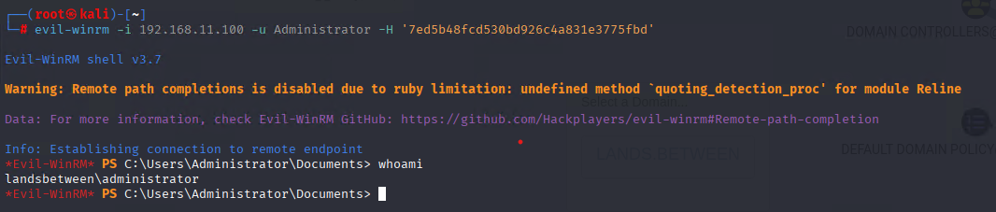
Figure 23: Administrator
(Source: Self-Created)

Flag Identification
During the penetration, two hidden flags were found and taken away as the final proof of the compromise.
First Flag: Situated in “C:\FrenziedFlame” directory under the file flag.txt. Upon reading the contents, it gave the following message:
FLAG - Burn the Erdtree. The age of chaos begins.
This flag confirmed that initial access to the system was granted and that some instance of file system enumeration was also carried out using the “nymir.runehunter” account.

Figure 24: Flag 1
(Source: Self-Created)
Second Flag: It was found inside the “Administrator's” Desktop folder at “C:\Users\Administrator\Desktop\flag.txt”. Upon the opening and reading of the said file, this flag was found:
FLAG - The path to grace lies buried beneath false thrones and forgotten roots. Only the Tarnished who endure flame, betrayal, and shadow may claim the Elden Crown.
The capture of this flag indicated a full domain compromise and administrative access.
Figure 25: Flag 2
(Source: Self-Created)

Security Recommendations
Strong recommendations are advised for the protection of the environment from exploitation or incidents revealed during the penetration testing.
- Strong Password Policy: Strong passwords, including length and variety of characters, will enable a change every 90 days (Güven et al., 2022). However, default easy passwords should never be allowed, e.g., passwords such as "password" or "zxcvbn”
- Audit Active Directory Permissions regularly: Review user permissions and ACLs regularly to revoke any that amount to excessive permissions, such as GenericAll, that may be utilized for unauthorized changes to an account.
- Use Multi-Factor Authentication: Require MFA for all types of privileged accounts and remote access methods to reduce the exposure of account or credential compromise.
- To prevent abuse, contain the attacker from hitting not only SMB and LDAP, items and services. SMB shares and LDAP services should be made only available to trusted networks and users (Karagiannakis & Καραγιαννάκης, 2025). Unneeded shares must be disabled, and their usage monitored for suspicious behavior.
- Monitor and Respond to Anomalous Behavior: Set up security monitoring applications that can detect abnormal authentication patterns, suspicious privilege escalation attempts, and network traffic patterns indicative of reconnaissance or exploitation attempts.
- Patch and Update: Keep the domain controllers and all other related infrastructure patched with the latest security updates to protect against known vulnerabilities

Conclusion
The penetration, a critical aspect of the Active Directory environment, weak password policies, excessive permissions, misconfigured ACLs that created unauthorized access, and allowed the elevation of countless privileges. Using default passwords and “GenericAll” permissions, the assessment exercise was able to reset user credentials and open remote shell access, thus severely compromising high-privilege accounts, including Administrator accounts. Two hidden flags were captured to conclusively prove the attacks as legitimate. Hence, enforcing complex passwords, reviewing user permissions to eliminate rights, and setting up multi-factor authentication on privileged accounts must be given strong emphasis (Kamaruddin & Zolkipli, 2024). Moreover, restricting access to critical services, such as SMB and LDAP, and logging that access will contribute to the attack surface limitation. These findings strongly recommend that organizations start assessing and hardening their Active Directory infrastructure to save themselves from facing a similar compromise. In essence, the test greatly demonstrates real-world attack scenarios that plague most enterprise networks and presents relevant recommendations to safeguard these networks from their ever-morphing adversaries.

References
Arogundade, O. R. (2023). Network security concepts, dangers, and defense best practices. Computer Engineering and Intelligent Systems, 14(2). https://doi.org/10.7176/ceis/14-2-03
Gkotsis, P. (n.d.). CREATING A WINDOWS ACTIVE DIRECTORY LAB AND PERFORMING SIMULATED ATTACKS. Retrieved May 30, 2025, from https://dione.lib.unipi.gr/xmlui/bitstream/handle/unipi/13427/Gkotsis_1805.pdf?sequence=1
Kamaruddin, C., & Zolkipli, M. F. (2024). The Role of Multi-Factor Authentication in Mitigating Cyber Threats. Borneo International Journal EISSN 2636-9826, 7(4), 35–42. http://majmuah.com/journal/index.php/bij/article/view/667
Kyriakou, P. (2023). Infrastructure Penetration Testing. https://ikee.lib.auth.gr/record/345496/files/GRI-2023-38338.pdf
Rivero, N. (2024). Improvement of security measures of a medical data management platform. Upc.edu. http://hdl.handle.net/2117/424643
Smirnov, E. (2024). Building Modern Active Directory. Apress. https://doi.org/10.1007/979-8-8688-0941-5
Mallick, A., & Nath, R. (2024). Navigating the Cyber security Landscape: A Comprehensive Review of Cyber-Attacks, Emerging Trends, and Recent Developments. https://worldscientificnews.com/wp-content/uploads/2024/01/WSN-1901-2024-1-69-1.pdf
Güven, E. Y., Boyaci, A., & Aydin, M. A. (2022). A Novel Password Policy Focusing on Altering User Password Selection Habits: A Statistical Analysis on Breached Data. Computers & Security, 113, 102560. https://doi.org/10.1016/j.cose.2021.102560
Karagiannakis, M., & Καραγιαννάκης, Μ. (2025). A Purple Team Playbook against Active Directory Certificate Services attacks. Unipi.gr. https://dione.lib.unipi.gr/xmlui/handle/unipi/17693

Appendices


Figure 26: Nmap Output
(Source: Self-Created)

Figure 27: Ldap enum
(Source: Self-Created)

Figure 28: user.txt
(Source: Self-Created)


Figure 29: Get Password
(Source: Self-Created)

Figure 30: Found Hash
(Source: Self-Created)

Figure 31: Crack Hash
(Source: Self-Created)
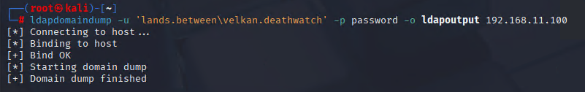
Figure 32: Domain Dump
(Source: Self-Created)
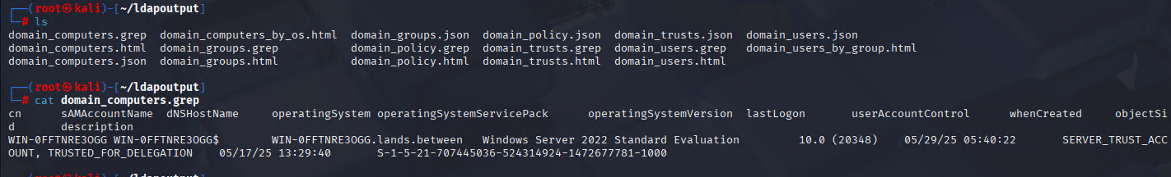
Figure 33: Ldap Dump Files
(Source: Self-Created)

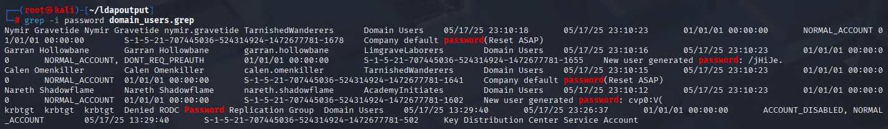
Figure 34: Some Users' Passwords
(Source: Self-Created)
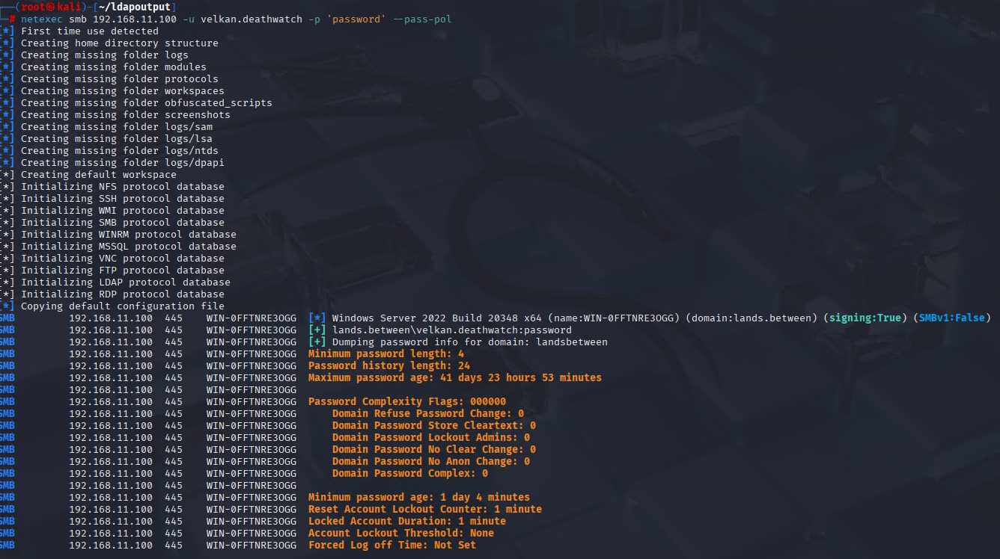
Figure 35: Password info
(Source: Self-Created)
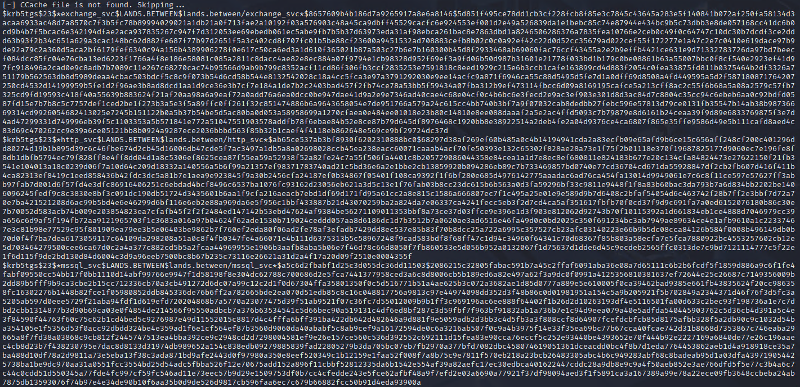
Figure 36: More hashes found
(Source: Self-Created)

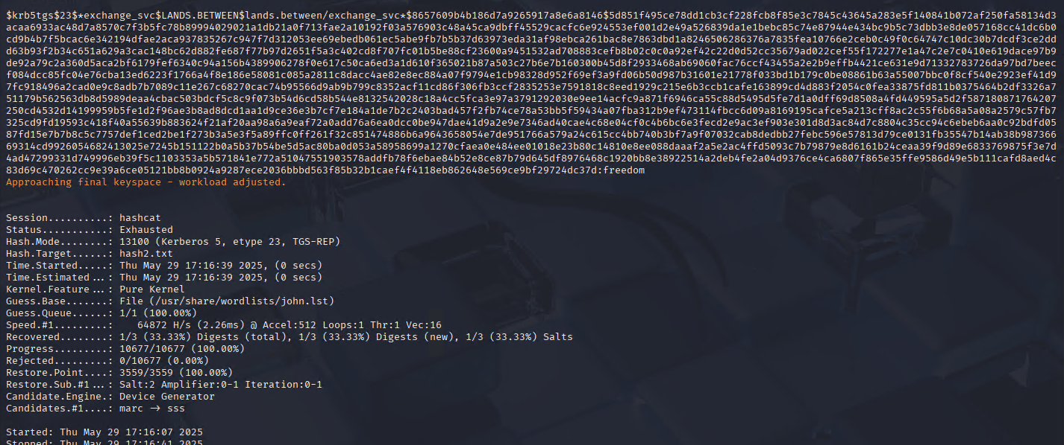
Figure 37: Hash Crack
(Source: Self-Created)
Figure 38: BloodHound File
(Source: Self-Created)
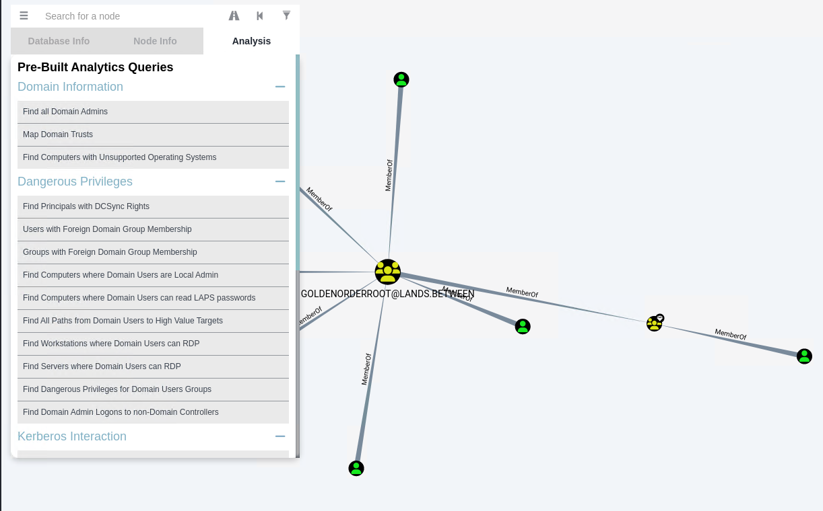
Figure 39: BloodHound GUI
(Source: Self-Created)

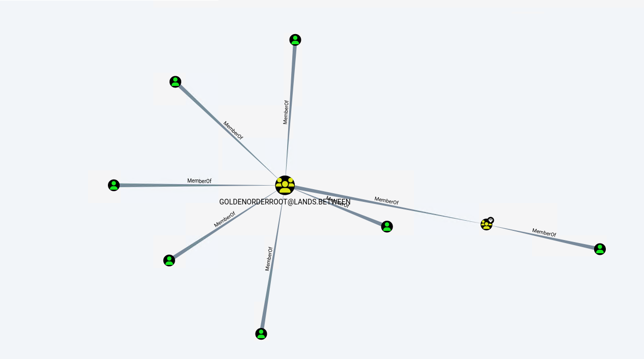
Figure 40: BloodHound GUI
(Source: Self-Created)
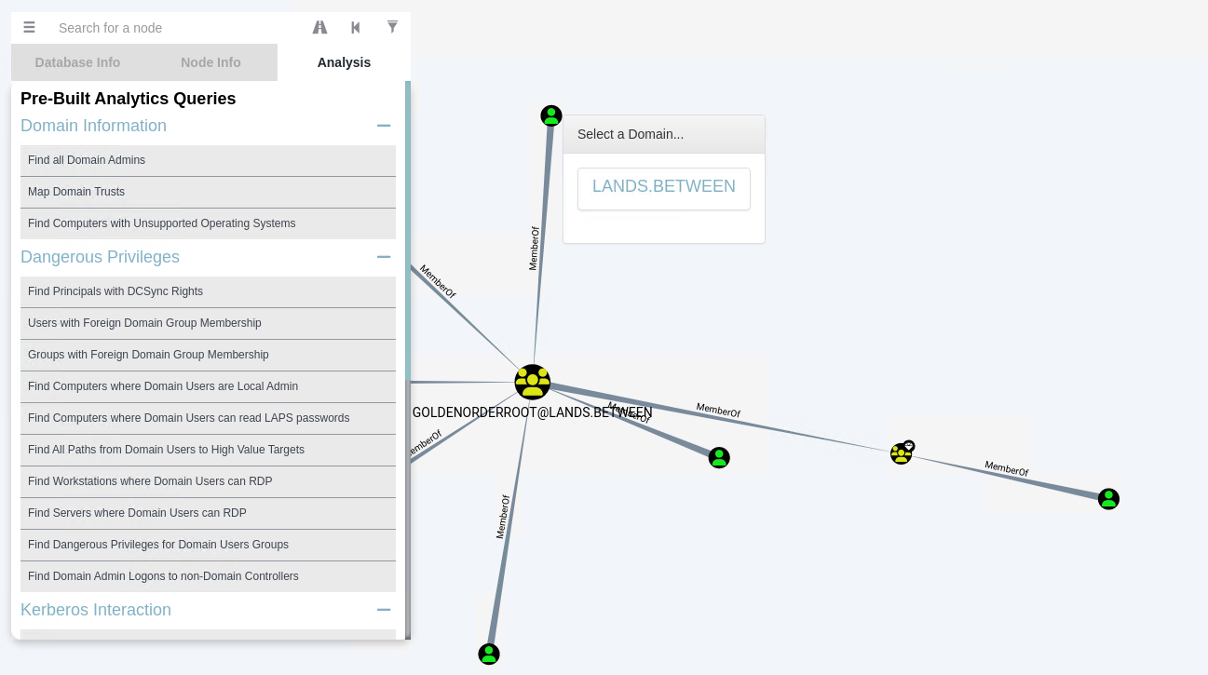
Figure 41: BloodHound GUI
(Source: Self-Created)

Figure 42: SmbClient
(Source: Self-Created)


Figure 43: SmbClient
(Source: Self-Created)


Figure 44: Default Password
(Source: Self-Created)
Figure 45: Status Check
(Source: Self-Created)

Figure 46: Change Password
(Source: Self-Created)

Figure 47: Evil-WinRM
(Source: Self-Created)

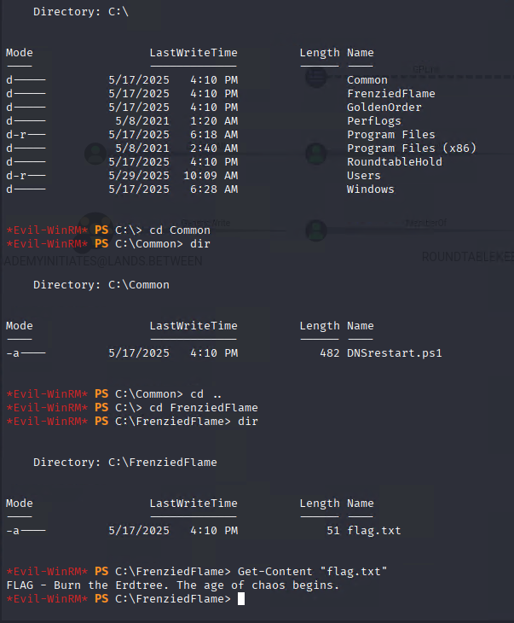
Figure 48: Flag.txt
(Source: Self-Created)

Figure 49: Found Flag
(Source: Self-Created)

Figure 50: password change
(Source: Self-Created)

Figure 51: Add Member
(Source: Self-Created)


Figure 52: Dump Administrator Hash
(Source: Self-Created)

Figure 53: Evil-WinRM
(Source: Self-Created)
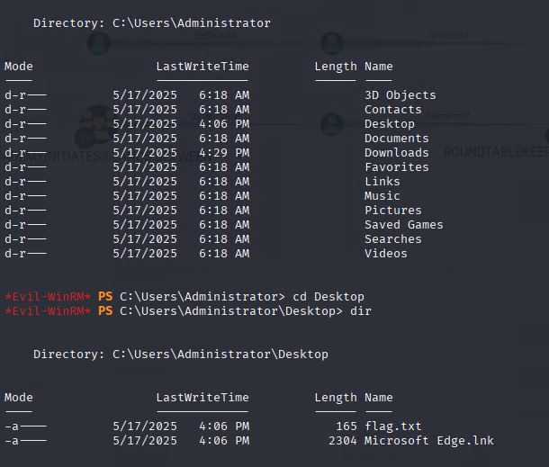
Figure 54: Administrator Access
(Source: Self-Created)
Figure 55: Found Second Flag
(Source: Self-Created)

